**The Research Participants Survey Results**

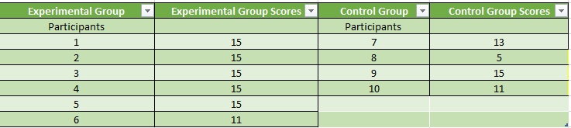

**The Analyzed Data**

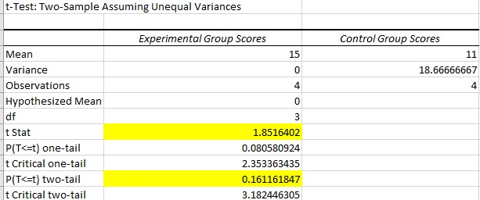

**The Experimental Group Respondents Scores**

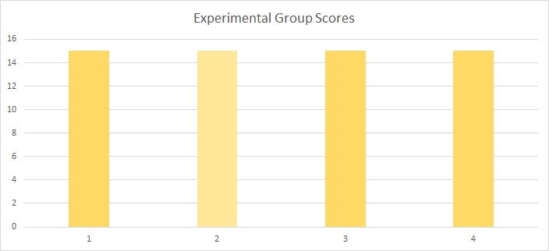

**The Control Group Respondents Scores**

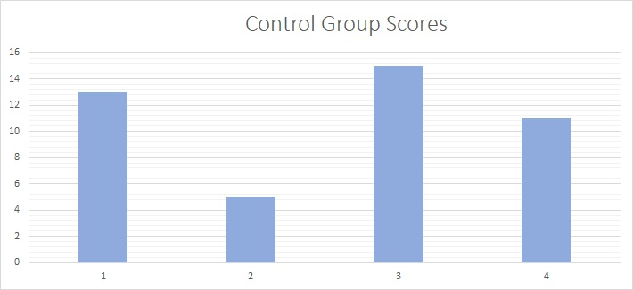

Results And Discussion:

In the quantitative phase of the research, the researchers behind Hue Got It Right: An Experimental Research on Tone of Lights and its Influence on Memory focusing on whether there is an effect on the tone of a lightbulb such as the cool or warm light during the twenty minute study sessions pre-conducted on the Bataan Peninsula State University Psychology on their memory retention during the following exam given by the researchers. The Microsoft Excel Data Analysis toolpak was utilized particularly the T-test independent hypothesis testing method in order to perform data treatment on their experimental findings.

The main purpose of the researchers using the T-test independent was in order to examine if the two groups of respondents both in the Bataan Peninsula State University Psychology program, one a control and one an experimental group had a significant difference in their test scores and memory retention when exposed to two different kinds of light tones. The test was conducted in order to uncover if there was a relationship or correlation between the tone of light that a student utilizes during their study session and their memory retention capabilities upon answering an examination. It is important to note that the test utilized here by the researchers which was the American civil war is a test that is completely unrelated, unbiased and was suitable for the study as it prevented preconceived factors that where outside the researchers control such as prior knowledge, retention and recalling abilities and overall familiarity of the respondents to the test questionnaire being used in the study. The parametric test T-test independent calculated the T-statistic and the P-value otherwise known as the alpha for both the test scores of the experimental and control group in order to assess if there was a correlation or relationship between the two groups test scores and their exposure to two different tones of light.

According to the results, the T-statistic in both the experimental and the control group are both larger than the alpha or the P-value, which means in the rule of statistics and hypothesis testing that there is not a statistical significance between both the experimental and research groups test scores and the tone of light that they have used in order to prepare for their academic gradings.

The researchers have concluded to accept the null hypothesis, and that there is not a statistical significance between one’s tone of lighting and their memory retention when it came to test taking.